CAPSTONE PROJECT WEEKLY ACCOMPLISHMENT REPORT

Team Name: COREX Section: BSIT-3A Date: February 16-22
Project Title: AUTOMATED EVENT SCORING MANAGEMENT AND TABULATION SYSTEM FOR SCHOOL ACTIVITIES

Accomplishment for the Week

Task / Activity | Description of Work Done | 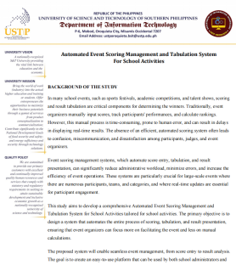  Output / Evidence
Finalizing the new Concept Paper | Reviewed the concept paper, ensuring that the objectives, problem, solution and significance of the study were clearly stated also adding the suggested feedback from the panelist.
System Architecture Design | Designed the System Architecture to facilitate the visualization of the proposed system's structural flow, components, and integration. | 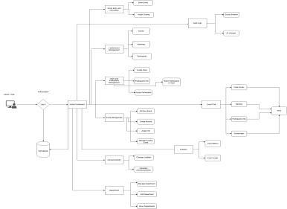
Pitch Deck Preparation | The team design a pitch deck presentation to effectively convey the value proposition of the project to the panel. | 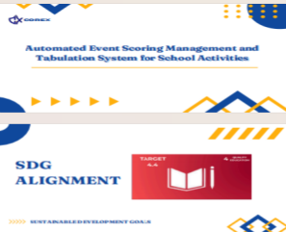
Concept Hearing (Round 2) | During the second proposal, the project concept was presented, preliminary concerns were addressed, and the panelist provided feedback. | 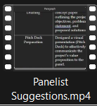

Individual Contribution

Team Member | Contribution
Gellyn S. Rabino | Documenter
Arlyn Kaye Allona D. Baluyos | Quality Assurance
Johny M. Roldan | Data / Analysis Specialist
Ian Kirby B. Duman-ag | Project Manager / Team Leader

Issues Encountered and Actions Taken

Issue/Concern | Action Taken / Resolution
Rejection of the Initial Concept | The team's focus was promptly redirected to the new project scope after accepting the panel's recommended system.
Inadequate Validation of Specific Problems | The system's specific data requirements, desired solutions, and actual problems were identified through a rapid user and client interview.

Plan for the Next Week

Planned Task | Expected Output
Chapter 1 Drafting | Chapter 1 Introduction.
Designing a UI for the web | Created and planned the layout and design of the system’s user interface.
File and Folder Structure | Conducted research on AI, community, and social media platforms.

Adviser’s Remarks

Reviewed by:

Mr. Hanes A. Ongos
Capstone Project Adviser
Date Signed:

Note:

- This report shall be submitted weekly to the Capstone Adviser.
- All members must actively contribute and be reflected in the report.
- Supporting evidence (screenshots, documents, commitments, etc.) may be attached.
- Submission of this report forms part of the progress monitoring and individual assessment of the Capstone Project.

